 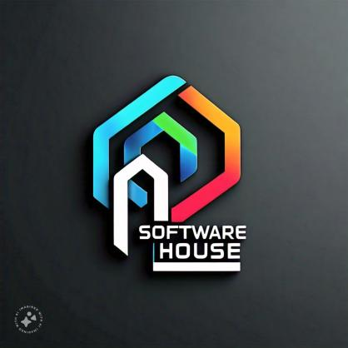

**BUISNESS PROPOSAL MADE BY JUNAID UL HAQUE SHEIKH S/O ABDUL HAQUE SHEIKH GIAIC 00457578 STUDENTS ONLY FRIDAY TIMING 02PM TO 05PM**

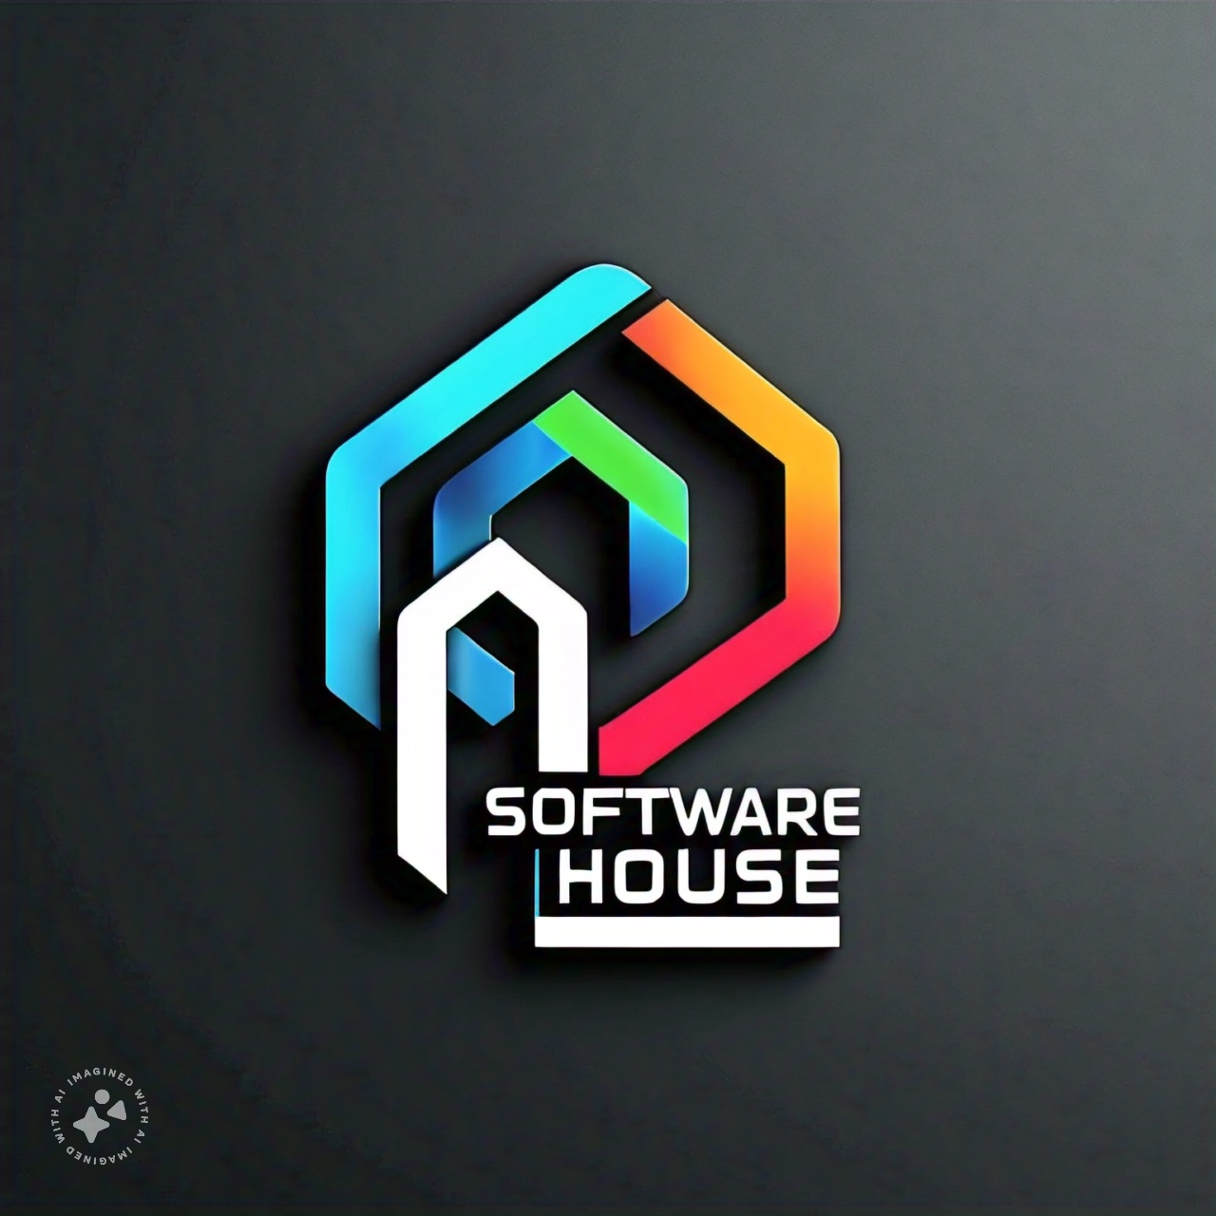



**Table Of Contents Only**

**02 Executive Summary Summary**

**03 Problem Statement**

**04 Proposal Solution**

**05 Market Trends**

**06 Buisness Operations Plans**

**07 Marketing & Sales**

**08 Financial Projections**

**09 Team**

**10 Conclusion**

**ON MAY 2025 INSHALLAH TALLAH**

**MAY BE ALLAH PEACEFULL WITH US**



Project

# Summary

* Business idea :
* Certainly! Here are some business proposal ideas for software houses:
* ****Custom Software Development Services****: Offer tailor-made software solutions for businesses across various industries. Highlight your expertise in developing software applications, websites, mobile apps, and other digital solutions that meet specific client needs.
* ****Product Development Partnership****: Collaborate with startups or established businesses to develop software products. Propose a partnership model where you provide the technical expertise to build the product while sharing ownership or revenue.
* ****Software Maintenance and Support****: Provide ongoing maintenance and support services for existing software applications. Emphasize the importance of regular updates, bug fixes, and technical support to ensure the smooth functioning of critical business systems.
* ****Cloud Migration Services****: Help businesses migrate their on-premises software applications to cloud platforms such as AWS, Azure, or Google Cloud. Highlight the benefits of cloud computing, such as scalability, cost-efficiency, and improved accessibility.
* ****Cybersecurity Solutions****: Offer cybersecurity services to protect businesses from cyber threats and data breaches. Develop and implement security measures such as encryption, firewalls, intrusion detection systems, and regular security audits.
* ****AI and Machine Learning Solutions****: Develop AI-powered software solutions that leverage machine learning algorithms to automate tasks, analyze data, and improve business processes. Showcase case studies and success stories to demonstrate the effectiveness of your AI solutions.
* ****Blockchain Development Services****: Explore opportunities in blockchain technology by offering development services for blockchain-based applications, smart contracts, and decentralized finance (DeFi) solutions. Highlight the transparency, security, and immutability features of blockchain technology.
* ****ERP Implementation and Integration****: Specialize in implementing and integrating Enterprise Resource Planning (ERP) systems for businesses. Offer services such as system customization, data migration, training, and ongoing support to optimize business operations.
* ****Internet of Things (IoT) Solutions****: Develop IoT applications and platforms that connect devices, sensors, and machines to collect and analyze data in real-time. Offer industry-specific IoT solutions for sectors such as manufacturing, healthcare, agriculture, and smart cities.
* ****Digital Transformation Consulting****: Provide consulting services to help businesses embrace digital transformation and leverage technology to drive innovation and growth. Offer strategic advice, technology assessments, and roadmap development to guide businesses through their digital transformation journey.
* When creating your business proposal, make sure to tailor it to the specific needs and objectives of your target audience. Highlight your company's expertise, experience, and unique value proposition to stand out in the competitive software industry.
* Business objective :
* The business objective for a software house could be multifaceted, but a common overarching goal is to become a leading provider of innovative and reliable software solutions while maintaining sustainable growth and profitability. Here's a breakdown of key business objectives for a software house:
* ****Deliver High-Quality Software Solutions****: Strive to consistently deliver software products and services that meet or exceed client expectations in terms of functionality, reliability, usability, and performance. Emphasize a commitment to quality assurance processes and continuous improvement to ensure customer satisfaction.
* ****Innovate and Adapt****: Stay at the forefront of technological advancements and industry trends by investing in research and development. Foster a culture of innovation within the organization to encourage creativity, experimentation, and the exploration of new ideas and technologies.
* ****Customer Satisfaction and Retention****: Focus on building strong relationships with clients by understanding their needs, providing personalized solutions, and delivering exceptional customer service. Aim to achieve high levels of customer satisfaction and retention through effective communication, responsiveness, and value-added services.
* ****Expand Market Presence****: Identify new market opportunities and target industries where there is a demand for software solutions. Develop marketing strategies to raise awareness of your brand, differentiate your offerings from competitors, and attract new clients.
* ****Forge Strategic Partnerships****: Collaborate with technology partners, industry associations, and other stakeholders to expand your network, access new markets, and enhance your capabilities. Seek strategic partnerships that complement your strengths and enable you to offer comprehensive solutions to clients.
* ****Attract and Retain Top Talent****: Recruit and retain talented professionals with expertise in software development, engineering, design, and other relevant domains. Create a supportive and inclusive work environment that fosters employee growth, satisfaction, and loyalty.
* ****Financial Sustainability and Growth****: Achieve sustainable financial performance by managing costs, optimizing resource allocation, and maximizing revenue streams. Set ambitious but realistic growth targets and develop strategies to achieve them while maintaining profitability and financial stability.
* ****Operational Excellence****: Streamline internal processes, workflows, and systems to enhance operational efficiency, productivity, and agility. Implement best practices in project management, resource allocation, and performance measurement to ensure projects are delivered on time and within budget.
* ****Maintain Compliance and Security****: Prioritize data security, privacy, and regulatory compliance to protect client information and mitigate risks. Stay informed about relevant laws, regulations, and industry standards and ensure that your software solutions adhere to the highest standards of security and compliance.
* ****Corporate Social Responsibility (CSR)****: Demonstrate a commitment to social and environmental responsibility by integrating CSR initiatives into your business practices. Support community engagement, environmental sustainability, and ethical business conduct to contribute positively to society while enhancing your brand reputation.
* By setting clear and measurable objectives aligned with these key areas, a software house can chart a strategic course for success and drive continuous improvement and growth.



Overall, a well-written project summary can help stakeholders understand the project's significance and potential impact.



**02**

Problem

# Statement

* Certainly! Here are some problem statements that a software house could address through its services and solutions:
* ****Legacy System Modernization****: Many businesses are burdened by outdated legacy systems that are inefficient, difficult to maintain, and lack scalability. The challenge lies in modernizing these systems to meet current business needs while minimizing disruption to operations.
* ****Cybersecurity Vulnerabilities****: With the increasing frequency and sophistication of cyber threats, businesses face the challenge of securing their digital assets and protecting sensitive data from breaches, malware, ransomware, and other cyberattacks.
* ****Lack of Customization****: Off-the-shelf software solutions may not fully meet the unique requirements and workflows of businesses in certain industries or niche markets. Customization is often needed to tailor software to specific business processes and preferences.
* ****Integration Complexity****: Businesses operate with a multitude of software applications and systems that need to seamlessly integrate and communicate with each other. The challenge lies in integrating disparate systems to streamline processes, improve data flow, and enable better decision-making.
* ****Limited Scalability****: As businesses grow and evolve, their software systems must be able to scale to accommodate increasing volumes of users, transactions, and data. Scalability challenges arise when existing systems cannot handle growing demands or require significant reengineering to scale effectively.
* ****User Experience (UX) Issues****: Poor user experience can hinder software adoption and productivity, leading to dissatisfaction among employees or customers. Addressing usability issues, accessibility concerns, and performance bottlenecks is crucial to enhancing user satisfaction and engagement.
* ****Data Management and Analytics****: Businesses struggle with managing and extracting value from large volumes of data generated from various sources. The challenge lies in effectively storing, organizing, analyzing, and visualizing data to derive actionable insights and drive informed decision-making.
* ****Compliance and Regulatory Requirements****: Industries such as healthcare, finance, and retail are subject to stringent regulatory requirements and compliance standards. Ensuring that software systems comply with relevant regulations, such as GDPR, HIPAA, or PCI-DSS, can be complex and resource-intensive.
* ****Remote Work Enablement****: The shift to remote work has accelerated the demand for digital collaboration tools, cloud-based solutions, and secure remote access to corporate systems. Addressing the challenges of remote work, such as connectivity issues, data security risks, and collaboration barriers, is essential for businesses to thrive in a remote-first environment.
* ****Innovation Gap****: Businesses need to continually innovate and stay ahead of competitors to remain relevant in a rapidly evolving marketplace. The challenge lies in fostering a culture of innovation, identifying emerging technologies and trends, and translating innovation into tangible products or services that create value for customers.
* By addressing these problem statements with innovative solutions and services, a software house can position itself as a trusted partner that helps businesses overcome challenges, drive digital transformation, and achieve their strategic objectives.

 **02**

Proposed

# Solution

* Certainly! Here's a proposed solution that a software house could offer to address the problem statements mentioned earlier:
* ****Integrated Digital Transformation Platform****
* ****Overview:**** Our proposed solution is an Integrated Digital Transformation Platform designed to empower businesses to overcome challenges related to legacy system modernization, cybersecurity vulnerabilities, lack of customization, integration complexity, limited scalability, user experience issues, data management and analytics, compliance, remote work enablement, and innovation.
* ****Key Features:****
* ****Modular Architecture****: The platform is built on a modular architecture that allows businesses to seamlessly integrate and customize modules based on their specific needs and requirements.
* ****Modernization Tools****: A suite of tools and services is provided to assist businesses in modernizing their legacy systems, including code refactoring, API integration, and containerization, to improve agility, scalability, and maintainability.
* ****Security Framework****: The platform incorporates robust security measures, including encryption, multi-factor authentication, intrusion detection, and continuous monitoring, to safeguard against cyber threats and ensure compliance with industry regulations.
* ****Customization Capabilities****: Businesses can easily customize and extend the platform to align with their unique workflows, processes, and branding requirements, without compromising on scalability or interoperability.
* ****Integration Hub****: An integration hub facilitates seamless communication and data exchange between disparate systems and applications, leveraging APIs, web services, and middleware to streamline business processes and improve data accuracy and consistency.
* ****Scalability and Performance****: The platform is designed to scale horizontally and vertically to accommodate growing workloads and user bases, with built-in performance optimization features to ensure responsive and efficient operation.
* ****User-Centric Design****: A focus on user-centric design principles ensures an intuitive and engaging user experience across all devices and interfaces, promoting user adoption and productivity.
* ****Advanced Analytics****: Built-in analytics capabilities enable businesses to gain valuable insights from their data, with features such as dashboards, reports, predictive analytics, and machine learning algorithms to support data-driven decision-making and business intelligence.
* ****Compliance Toolkit****: A comprehensive compliance toolkit provides pre-built templates, workflows, and audit trails to facilitate compliance with regulatory requirements such as GDPR, HIPAA, PCI-DSS, and SOX, reducing compliance risks and overhead.
* ****Remote Work Enablement****: The platform includes collaboration tools, document management, video conferencing, and secure remote access features to support seamless remote work operations and virtual collaboration, ensuring business continuity and employee productivity.
* ****Benefits:****
* Accelerated Digital Transformation: Businesses can accelerate their digital transformation initiatives with a scalable, secure, and customizable platform that addresses their specific challenges and requirements.
* Enhanced Security and Compliance: Robust security measures and compliance features help businesses mitigate cybersecurity risks and ensure regulatory compliance, protecting sensitive data and maintaining trust with customers and stakeholders.
* Improved Efficiency and Productivity: Streamlined workflows, integrated systems, and user-friendly interfaces enhance efficiency and productivity, enabling employees to focus on value-added tasks and innovation.
* Greater Agility and Innovation: Modular architecture and customization capabilities enable businesses to adapt quickly to changing market conditions and emerging technologies, fostering a culture of innovation and competitive advantage.
* Seamless Remote Work Operations: Remote work enablement features empower businesses to support flexible work arrangements and remote collaboration, ensuring business continuity and employee satisfaction.
* By offering an Integrated Digital Transformation Platform, our software house aims to empower businesses to overcome their most pressing challenges and achieve sustainable growth and success in the digital age.
* 窗体顶端
* 窗体底端

 **02**

Market

# Trend

* Keeping abreast of market trends is crucial for any software house to stay competitive and relevant. Here are some significant market trends in the software industry:
* ****Cloud Computing****: The adoption of cloud computing continues to rise, driven by its scalability, flexibility, and cost-effectiveness. Businesses are increasingly migrating their software applications and infrastructure to cloud platforms such as AWS, Azure, and Google Cloud to enhance agility, innovation, and efficiency.
* ****Artificial Intelligence (AI) and Machine Learning (ML)****: AI and ML technologies are being integrated into software solutions to automate tasks, analyze data, and provide intelligent insights. Businesses are leveraging AI-powered chatbots, recommendation engines, predictive analytics, and image recognition to enhance customer experiences, optimize operations, and drive innovation.
* ****Internet of Things (IoT)****: The proliferation of IoT devices and sensors is generating vast amounts of data that businesses can leverage to gain valuable insights and improve decision-making. IoT technologies are being used in various industries, including manufacturing, healthcare, transportation, and smart cities, to enable real-time monitoring, predictive maintenance, and process optimization.
* ****Edge Computing****: Edge computing is gaining momentum as businesses seek to process and analyze data closer to the source of its generation, reducing latency and bandwidth usage. Edge computing technologies enable real-time decision-making and action in distributed environments, such as IoT devices, autonomous vehicles, and remote industrial sites.
* ****Cybersecurity****: With the increasing frequency and sophistication of cyber threats, cybersecurity remains a top priority for businesses across all industries. Demand is rising for advanced cybersecurity solutions, such as threat intelligence, endpoint detection and response (EDR), and zero-trust security architectures, to protect against data breaches, ransomware attacks, and other cyber threats.
* ****Low-Code/No-Code Development****: Low-code and no-code development platforms are empowering citizen developers and business users to create software applications with minimal coding knowledge. These platforms enable faster application development, rapid prototyping, and greater collaboration between IT and business teams, accelerating digital innovation and reducing time-to-market.
* ****DevOps and Agile Practices****: DevOps and Agile methodologies continue to gain traction as businesses strive to deliver software faster, with higher quality and reliability. DevOps practices, such as continuous integration, continuous delivery (CI/CD), and infrastructure as code (IaC), enable automation, collaboration, and faster time-to-value, fostering a culture of innovation and continuous improvement.
* ****Big Data Analytics****: The proliferation of data from various sources, including IoT devices, social media, and online transactions, is driving demand for big data analytics solutions. Businesses are leveraging big data technologies, such as Hadoop, Spark, and Kafka, to analyze large volumes of structured and unstructured data, uncover hidden insights, and make data-driven decisions.
* ****Remote Work and Collaboration Tools****: The shift to remote work has accelerated the adoption of collaboration tools, video conferencing platforms, and remote access solutions. Businesses are investing in technologies that enable seamless communication, collaboration, and productivity among remote teams, ensuring business continuity and employee engagement in a distributed work environment.
* ****Sustainability and Green IT****: There is growing awareness and emphasis on sustainability and environmental responsibility in the software industry. Businesses are increasingly adopting green IT practices, such as energy-efficient data centers, carbon footprint reduction initiatives, and eco-friendly software development practices, to minimize environmental impact and promote sustainability.
* By staying informed about these market trends and aligning their offerings and strategies accordingly, software houses can capitalize on emerging opportunities, address evolving customer needs, and maintain a competitive edge in the dynamic software industry.
* 窗体顶端

窗体底端

 **02**

Operational

# Plan

* Developing effective operational plans is essential for a software house to efficiently execute its strategies and deliver high-quality products and services. Here's a framework for operational plans tailored to the needs of a software house:
* ****Project Management Methodology****: Adopt a robust project management methodology, such as Agile, Scrum, or Kanban, to streamline development processes, improve collaboration, and deliver projects on time and within budget. Define clear roles and responsibilities, establish project milestones and timelines, and implement tools for project tracking and communication.
* ****Resource Allocation and Capacity Planning****: Conduct thorough resource allocation and capacity planning to ensure that projects are adequately staffed with skilled professionals and necessary resources. Regularly assess resource availability, skills gaps, and project demands to optimize resource allocation and utilization.
* ****Quality Assurance and Testing****: Implement rigorous quality assurance (QA) and testing processes to ensure the reliability, security, and performance of software products. Define QA standards, conduct thorough testing at each stage of the development lifecycle, and utilize automated testing tools and techniques to identify and resolve defects efficiently.
* ****Continuous Integration and Deployment (CI/CD)****: Embrace CI/CD practices to automate the build, test, and deployment processes, enabling faster delivery of software updates and enhancements. Implement CI/CD pipelines, version control systems, and automated testing frameworks to accelerate development cycles and improve software quality.
* ****Customer Relationship Management (CRM)****: Implement a CRM system to manage customer interactions, track sales opportunities, and nurture client relationships effectively. Capture customer feedback, address inquiries and issues promptly, and leverage CRM data to identify upselling and cross-selling opportunities.
* ****Training and Development****: Invest in training and development programs to enhance the skills and knowledge of employees, ensuring that they stay updated on the latest technologies, methodologies, and industry trends. Offer certifications, workshops, and mentorship programs to foster continuous learning and professional growth.
* ****Vendor and Partner Management****: Establish strong relationships with vendors, technology partners, and third-party service providers to complement your in-house capabilities and expand your service offerings. Evaluate vendors based on criteria such as reliability, expertise, and cost-effectiveness, and maintain open communication to address any issues or concerns proactively.
* ****Security and Compliance Measures****: Prioritize security and compliance measures to protect sensitive data, mitigate cybersecurity risks, and ensure regulatory compliance. Implement robust security policies, conduct regular security audits and assessments, and stay updated on relevant laws and regulations to maintain a secure and compliant operating environment.
* ****Performance Monitoring and Optimization****: Monitor key performance indicators (KPIs) related to project delivery, resource utilization, customer satisfaction, and financial performance. Identify areas for improvement, implement process optimizations, and leverage data-driven insights to enhance operational efficiency and effectiveness continuously.
* ****Disaster Recovery and Business Continuity****: Develop comprehensive disaster recovery and business continuity plans to mitigate the impact of potential disruptions, such as hardware failures, cyberattacks, or natural disasters. Establish backup and recovery procedures, implement redundant systems and infrastructure, and conduct regular drills and simulations to ensure readiness for emergencies.
* By implementing these operational plans, a software house can optimize its internal processes, enhance collaboration and communication, mitigate risks, and deliver exceptional value to clients, positioning itself for long-term success and growth in the competitive software market.

Marketing &

# Sales

* Developing effective marketing and sales strategies is crucial for a software house to attract clients, generate leads, and drive revenue growth. Here's a comprehensive approach to marketing and sales tailored to the needs of a software house:
* ****Marketing Strategies:****
* ****Targeted Marketing Campaigns****: Identify target market segments based on industry verticals, company size, geographic location, and specific needs. Develop tailored marketing campaigns and messaging to address the pain points and challenges of each segment.
* ****Content Marketing****: Create high-quality, educational content such as blog posts, whitepapers, case studies, and videos that showcase your expertise, highlight customer success stories, and provide valuable insights into industry trends and best practices.
* ****Search Engine Optimization (SEO)****: Optimize your website and content for relevant keywords and phrases to improve search engine rankings and attract organic traffic. Focus on creating valuable, relevant content that resonates with your target audience and drives engagement.
* ****Social Media Marketing****: Leverage social media platforms such as LinkedIn, Twitter, and Facebook to engage with prospects, share valuable content, and build brand awareness. Participate in industry discussions, join relevant groups and communities, and interact with potential clients to establish credibility and trust.
* ****Email Marketing****: Build and nurture relationships with prospects and leads through targeted email marketing campaigns. Segment your email lists based on factors such as industry, role, and stage in the buying cycle, and personalize your messages to address the specific needs and interests of each segment.
* ****Thought Leadership and Public Relations****: Position your company as a thought leader in the software industry by contributing articles to industry publications, speaking at conferences and events, and participating in panel discussions and webinars. Establish relationships with journalists and media outlets to secure press coverage and media mentions.
* ****Partnerships and Alliances****: Collaborate with complementary businesses, technology partners, and industry influencers to expand your reach, access new markets, and leverage each other's networks and resources. Explore co-marketing opportunities, joint events, and referral programs to drive mutual growth and success.
* ****Sales Strategies:****
* Certainly! Here are some effective sales strategies for a software house:
* ****Identify Target Markets and Ideal Customer Profiles****: Begin by identifying the industries, sectors, and businesses that are most likely to benefit from your software solutions. Develop detailed buyer personas and ideal customer profiles based on factors such as company size, industry vertical, pain points, and buying behaviors.
* ****Build a Strong Value Proposition****: Clearly articulate the unique value proposition of your software solutions and how they address the specific needs and challenges of your target audience. Highlight key features, benefits, and competitive advantages that set your offerings apart from competitors.
* ****Develop a Multi-Channel Sales Approach****: Utilize a combination of inbound and outbound sales channels to reach potential clients and engage with them at various stages of the buying cycle. This may include inbound marketing tactics such as content marketing, SEO, and social media, as well as outbound tactics such as email marketing, cold calling, and networking.
* ****Establish Thought Leadership and Expertise****: Position your company and sales team as trusted advisors and experts in the software industry. Share valuable insights, best practices, and industry trends through thought leadership content, webinars, speaking engagements, and participation in relevant forums and communities.
* ****Qualify Leads Effectively****: Implement a robust lead qualification process to identify high-quality leads that are most likely to convert into customers. Develop criteria for lead scoring and qualification based on factors such as fit, interest level, budget, authority, and timeline.
* ****Customize Sales Presentations and Demonstrations****: Tailor sales presentations and product demonstrations to address the specific needs and requirements of each prospect. Focus on showcasing how your software solutions can solve their problems, meet their objectives, and deliver tangible ROI.
* ****Offer Proof of Concept (POC) or Pilot Programs****: Provide prospects with the opportunity to test-drive your software solutions through proof of concept (POC) or pilot programs. This allows them to experience the value and benefits firsthand before making a commitment, reducing perceived risk and increasing confidence in your offerings.
* ****Leverage Customer Success Stories and Case Studies****: Share success stories, case studies, and testimonials from satisfied customers to demonstrate the real-world impact and results of your software solutions. Use these examples to build credibility, overcome objections, and inspire confidence in your offerings.
* ****Build Strong Relationships and Follow-Up****: Invest time and effort in building strong relationships with prospects and clients through regular communication, follow-up, and engagement. Be responsive to inquiries, address concerns promptly, and provide exceptional customer service throughout the sales process and beyond.
* ****Focus on Long-Term Value and Upselling Opportunities****: Adopt a customer-centric approach focused on delivering long-term value and building ongoing relationships with clients. Look for opportunities to upsell or cross-sell additional products, services, or features that align with their evolving needs and objectives.
* By implementing these sales strategies effectively, a software house can attract, engage, and convert prospects into satisfied customers, driving revenue growth and business success in the competitive software market.

Financial

# Projection

* ***Creating a financial projection for a software house involves forecasting revenue, expenses, and profitability over a specific period, typically one to five years. Here's an outline of the key components to include in a financial projection:***
* *****Revenue Forecast****:***
* ***Break down revenue projections by product or service offering (e.g., custom software development, maintenance services, licensing fees).***
* ***Consider factors such as market demand, pricing strategy, sales pipeline, and historical sales data.***
* ***Project revenue growth over time, taking into account market trends, competitive landscape, and expansion plans.***
* *****Cost of Goods Sold (COGS)****:***
* ***Estimate the direct costs associated with delivering software solutions, such as labor costs, materials, and third-party licensing fees.***
* ***Calculate the gross margin by subtracting COGS from revenue to assess the profitability of each revenue stream.***
* *****Operating Expenses****:***
* ***Include fixed and variable operating expenses, such as salaries, rent, utilities, marketing expenses, professional services, and administrative costs.***
* ***Break down operating expenses into categories and allocate resources based on strategic priorities and business needs.***
* *****Profit and Loss Statement (P&L)****:***
* ***Summarize the revenue, COGS, and operating expenses to calculate the net income or net loss for each period.***
* ***Analyze the P&L statement to assess the overall financial performance and profitability of the software house.***
* *****Cash Flow Statement****:***
* ***Forecast cash inflows and outflows from operating activities, investing activities, and financing activities.***
* ***Monitor cash flow projections to ensure that the company has sufficient liquidity to meet its financial obligations and fund growth initiatives.***
* *****Balance Sheet****:***
* ***Summarize the company's assets, liabilities, and equity at a specific point in time.***
* ***Monitor key financial metrics such as liquidity ratios, leverage ratios, and return on investment to assess the company's financial health and stability.***
* *****Sensitivity Analysis****:***
* ***Conduct sensitivity analysis to evaluate the impact of changes in key assumptions (e.g., sales volume, pricing, costs) on financial outcomes.***
* ***Identify potential risks and opportunities and develop contingency plans to mitigate risks and capitalize on opportunities.***
* *****Scenario Planning****:***
* ***Develop multiple scenarios (e.g., best-case, worst-case, and base-case scenarios) to assess the range of possible outcomes and inform decision-making.***
* ***Adjust assumptions and variables in each scenario to reflect different market conditions, business strategies, and external factors.***
* *****Key Performance Indicators (KPIs)****:***
* ***Define and track KPIs such as revenue growth rate, gross margin, operating margin, customer acquisition cost (CAC), customer lifetime value (CLV), and churn rate.***
* ***Monitor KPIs regularly to evaluate performance, identify trends, and make data-driven decisions to optimize financial outcomes.***
* *****Review and Update****:***
* ***Regularly review and update the financial projection based on actual performance, market changes, and new insights.***
* ***Adjust assumptions, forecasts, and strategies as needed to stay agile and responsive to evolving business dynamics.***
* ***By developing a comprehensive financial projection, a software house can gain insights into its financial performance, assess the feasibility of its business strategies, and make informed decisions to achieve long-term growth and profitability.***

Our

# Team



**Aaron Loeb** Founder and CEO

**Jamie Chastain**

Director



**Olivia Wilson** Head of Marketing

**Morgan Maxwell** Head of Finance



 **05**

Contact

# Information



**Address ** Shanti Nagar Urdu Science College Near Sindhi Hotel Karachi

**Website ** [www.softwarehouse.com](http://www.reallygreatsite.com/)

**Phone ** +923359033554//+923343046525

Clear and accessible company contact information, including phone number, email address, physical address, and website, is crucial for building trust with customers and enhancing their overall experience.

